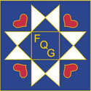
The Village Quilter
Fallbrook Quilt Guild
PO Box 1704
Fallbrook CA 92088 November 2026

Founded 1987
https://fallbrookquiltguild.com/
Facebook: Fallbrook Quilt Guild

Table of Contents  Celebrating November Birthdays 1  Message from the President 2  Message from 1st VPs 2  Threads of the Games 3  November Meeting 3  November Workshop 4  October Program 4  October Workshop 6  October Show and Tell 7  December Meeting and Potluck 11  February Meeting 11  February Workshop 11  Road 2 CA Bus Trip 12  Sunshine and Shadows 13  Year At a Glance 13 | 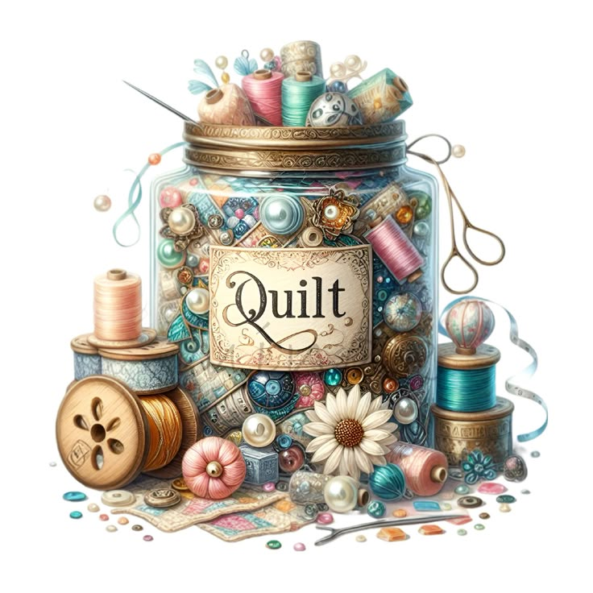


November Birthdays
01 – Lisa Felker
01 – Sandy Scott
02 – Jan Conklin
05 – Laura Small
06 – Viki Lewis
10 – Carol Wilson
15 – Ellen Papageorge
17 – Linda Rosensteel
20 – JoAnne Russell
22 – Donna Isaacs
23 – Donna Carter
24 – Tamara Kope
28 – Allyn Kaye
29 – Ann Turley

Message from the President
Quilters,
November brings us two beautiful reminders to slow down: gathering with loved ones for Thanksgiving and honoring our brave service members on Veterans Day. The Fallbrook Quilt Guild will honor several local veterans by gifting them handmade quilts at our November meeting. We look forward to welcoming their friends and family, who will be attending as our special guests.

I also want to extend a warm thank you to Dixie Johns and Connie Follstad for arranging our wonderful guest speaker for the October meeting. Karen Bolan did a fantastic job teaching us how to broaden our understanding and creative use of color in our quilting projects.

Speaking of color, have you considered finding fresh palette inspiration from our local Fallbrook landscape? Deep avocado greens, warm citrus oranges, and deep, ruby red pomegranates immediately come to mind. What local colors inspire you?

Upcoming Meeting Details
🗓️ Date: Thursday, October 1st
🚪 Doors Open: 12:30 PM
⏰ Meeting Starts: 1:00 PM
📍 Location: Fallbrook Community Center (341 Heald Lane, Fallbrook, CA)
👤 Guest Speaker: Arlene Stevens, representing the “California Heritage Quilt Project”

Please join us, connect with fellow members, and remember to bring your latest creations for our Show & Tell.

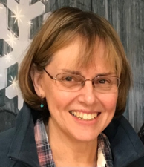
Ardis Duhachek
FQG President

Message from the 1st VP
At the October workshop, our body of knowledge about color has been stretched with the teaching of Karen Bolan. We experimented with afterimages which led to some audible ahhh sounds from workshop participants. Another hands-on experience was that about the concept of mutability which is the property of some colors that makes them appear different in different surroundings, with more ahhh utterances there too. Transparency was another special effect of color achieved by overlapping or a shining through effect. Last of all, was ample time to free play with the ample supply of solid-colored fabrics that Karen provided. See page 6 for some pictures showing what we learned.
There are a few spaces left for the November Holiday Patchwork Forest workshop led by Becky Forbes at a reduced cost of $25 for members and $40 for non-members. Contact Dixie if you want to be added to the list, down load your pattern, and cut some fabric out as directed below on page 4.

Threads of the Games
Threads of the Games is a coalition of Southern California Quilt Guilds in partnership with Road2CA, jurying and presenting an Olympic and Paralympic sport themed quilt exhibition in multiple venues around Los Angeles and Long Beach during the 2028 Games. Visit the website, www.threadsofthegames.org to find out more about the three challenges for quilters, the event timeline and how you can be involved.

- Small Quilt Challenge - Open to any single quilter or pair of quilters. Create a quilt with a required size of 24 inches by 24 inches square following the Exhibition Entry Rules.
- Quilt Guild Sport Lottery - Quilt guilds can enter a lottery to be assigned at random an Olympic or Paralympic sport to create a 65” X 85” quilt following the exhibition rules. Lottery entry will be open September 1, 2026 through November 30, 2026. Guilds will be informed of their randomly assigned sport December 3, 2026. Guild Lottery quilts must adhere to the same design requirements, restrictions and timelines. The goal is to have every Olympic and Paralympic sport represented.
- Open Quilt Challenge - Open to any single quilter or group of quilters. Create and enter a quilt of any size up to 85 inches by 85 inches (340” perimeter) following the Exhibition Entry Rules.

November Meeting
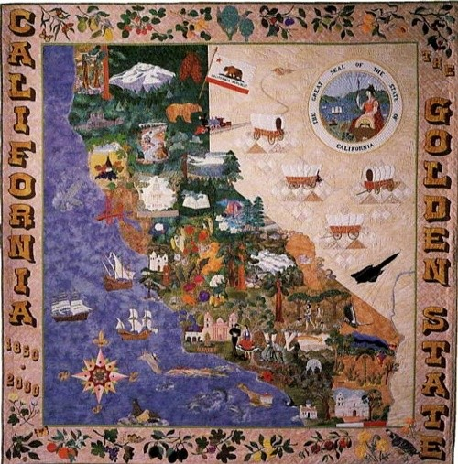
California Heritage Quilt Project

Honoring the Quilts and Quilters of California

Our special guest this month is Arlene Stevens, president of the California Heritage Quilt Project. She’ll give us some information about the project and how she got interested in it. They cover the history of the Project, and what they are doing now to document California quilts using the Quilt Index. The website is https://chqp.org/.

November Workshop
The workshop for November features Becky Forbes who will lead a workshop to duplicate her blue-ribbon tree quilt, Holiday Patchwork Forest.
All those bits of holiday fabric can be used to recreate this quilt.
No holiday fabric?
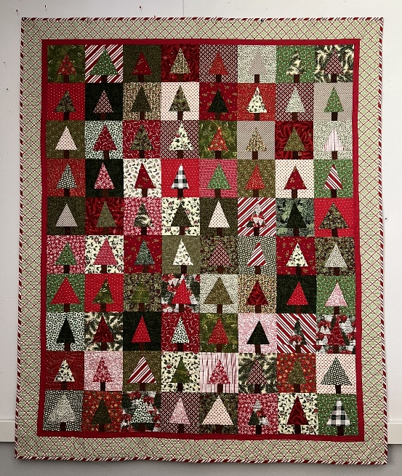
The Cottage has some newly acquired Christmas fabric. Use your discount on guild meeting day to save.

Original Patchwork Forest Quilt pattern where all blocks are uniform size. Improv-piecing makes this modern Christmas Tree quilt not only come together really quickly but makes each quilt totally unique. Easy to follow steps for making 2 blocks at once quickly, with minimal fabric waste.

Participants are to get their $3.50 PDF pattern in advance to the workshop at: https://diaryofaquiltershop.com/collections/downloadable-pdf-patterns/products/holiday-patchwork-forest-pattern-pdf. If you have any questions or difficulty purchasing & downloading the pattern, please contact Becky Forbes at 858-386-6558.

*Prior to the workshop, cut pairs of fabric 10 ½” x 8 ½”; The guild will have pairs of fabric this size, available for swapping so that you have a variety of fabrics for your quilt.

October Speaker
We enjoyed the presentation on color by Karen Bolan. She had many wonderful ideas for quilts.

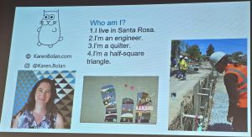 | 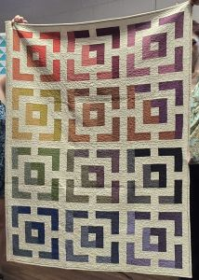

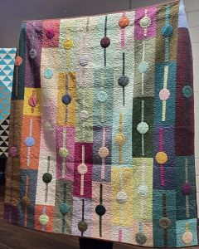 | 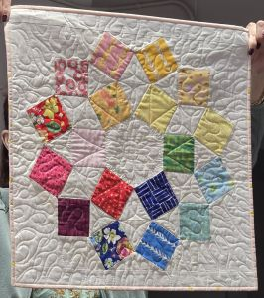

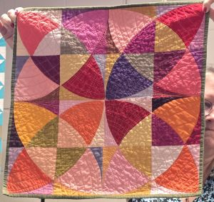 | 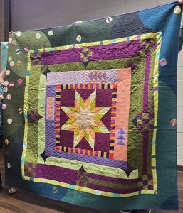

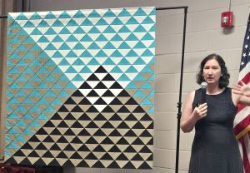 | 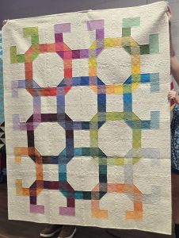

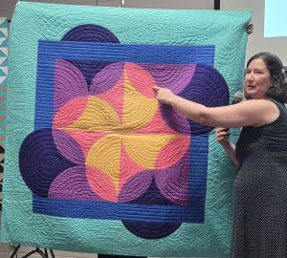 | 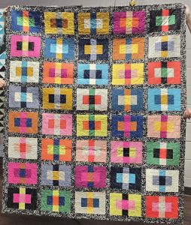

October Workshop
The October workshop with Karen was interesting. Here are some photos of the combinations we came up with.
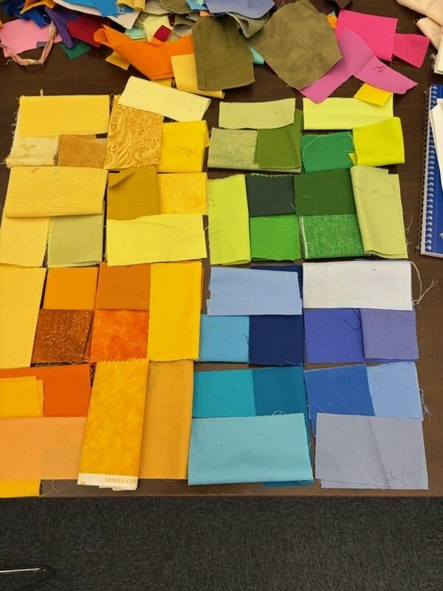 | 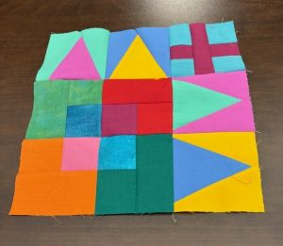

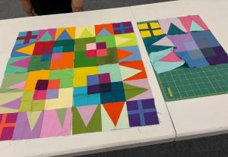 | 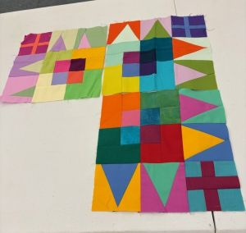

October Show and Tell
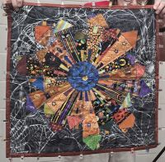  Cheryl’s UFO | 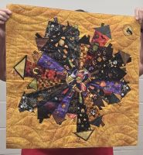  Cheryl’s houses

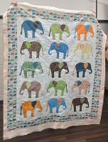  Cheryl’s elephants | 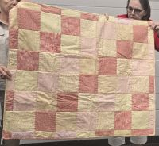  Ann’s flannel quilt

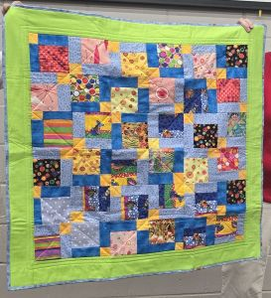  Ann’s flannel-backed UFO | 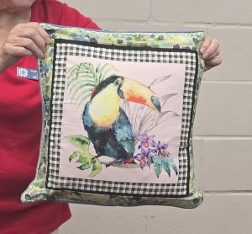  Allyn’s pillow

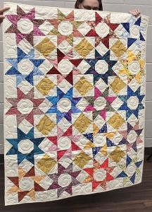  Penny’s quilt | 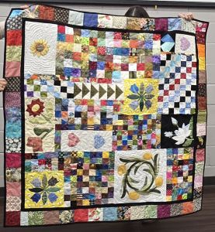  Penny’s miscellaneous blocks

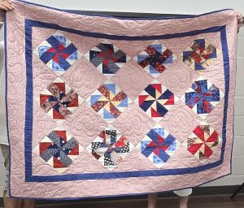  Penny’s UFO | 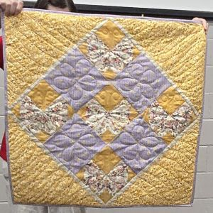  Penny’s UFO

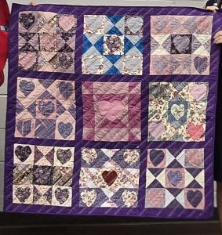  Catherine | 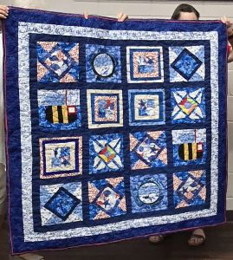  Catherine’s Washington Shop Hop

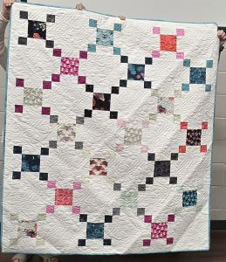  Linda’s Monday Night Class Uneven Nine Path | 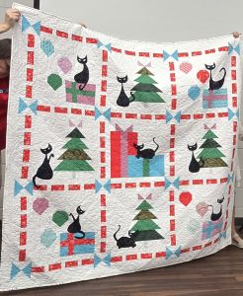  Linda’s Monday Night Class Mod Christmas

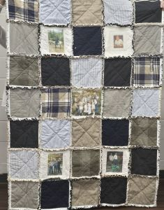  Tina’s memory quilt | 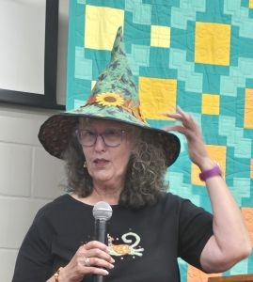  Jona’s Halloween hat

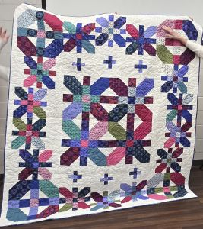  Sandy’s Coventry Garden | 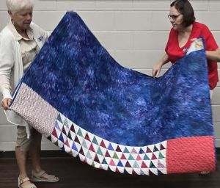  Back of Coventry Garden

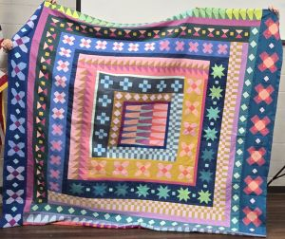  Jan Conklin unusual colors for her | 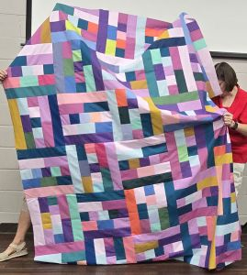  More unusual colors for Jan

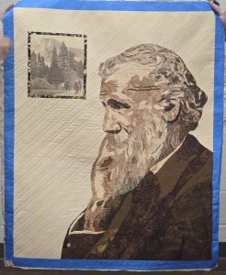  Karen’s John Muir portrait | 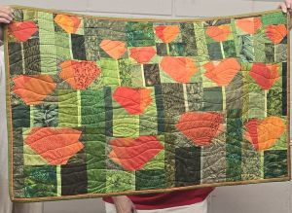  Nancy’s flowers

December Meeting and Potluck
Our usual fare for December includes the Christmas potluck which is always delicious. Besides the potluck, there will be a table game and prizes will be given.

February Meeting
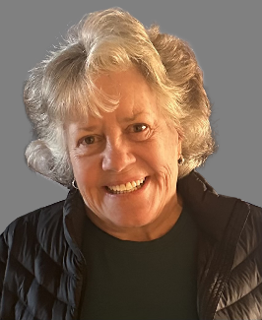
Dona McKenzie will join us this month to teach us about Studio 180. She is a certified instructor for this technique.

Also, this month we’ll have the drawing for the UFO Challenge. A new fabric challenge will be introduced, using a scrap of molas. The challenge will be revealed in June.

UFO Challenge Update
The UFO Challenge ends at our February meeting with drawings. First place is a $50 Costco gift card. 2nd and 3rd place are to be determined.
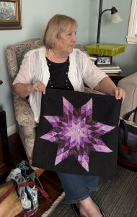
Get your red ticket by eliminating a UFO in your possession by either finishing it, giving it away, selling it, or disposing of it. For every UFO that you no longer own, you are entitled to a red ticket. So, bring it to guild, or send a picture of it to Dixie. Here’s a UFO from a long-ago star class that JoAnne Russell took. She turned it into an applique star on a pillow for her daughter.

February Workshop

Dona McKenzie will teach the Charleston Lily project. Members who choose to take this workshop will need to purchase the Wing Clipper I, available at https://studio180design.net/collections/wing-clipper/products/wing-clipper-1.

Road 2 CA Bus Trip


JUMP ON THE BUS!

The Fallbrook Quilt Guild plans to give back to its members with round trip bus transportation to Road to California on Friday, January 22, 2027! Our 56-seat passenger bus (with restroom) will leave the Old 395 / Hwy 76 Park & Ride at 8am, bus will return and leave Ontario Convention Center at 3pm to Fallbrook.

This will be a “Members Only” event! Cost is $28; which gets you a wristband to get into Road to California Show (quilt exhibits and expo/vender hall), tip to bus driver, snacks on bus with games & prizes!

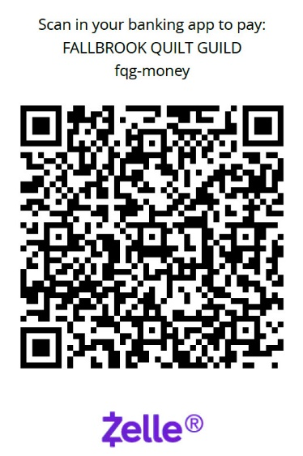
Tickets are on sale now! If tickets are still available after the December 3rd meeting, we will open event to non-members; which will cost $38. We will not hold your spot without full payment.

Please turn in payments to Becky Forbes. Cash, Zelle or checks made out to: Fallbrook Quilt Guild.

If you have any questions, please contact Becky Forbes
858-386-6558 or rebecca.k.forbes@gmail.com

Sunshine and Shadows
Chris Brewer is doing well after her back surgery. Here’s a message from her: “Thank you for asking! Slowly gaining strength and stamina. I actually got to sew the last few days. No pain.”


